xpedx.com Next generation
Reporting Design Document

Authors: Sterling Commerce

Date Created: 5/17/2010
Last Updated: 8/3/2010
File Name: C:\Documents and Settings\bfurman\My Documents\Temp\Methodology v1.1\Project Management\TEMPLATE - DOCUMENT - Use Case Definition.doc0000.doc

Approval Signatures (Mandatory)

Title | Name | Signature | Date | Comments / Issues / Concerns
xpedx Owner(s) | Steve Bugher
xpedx Owner(s) | Cheryl Tullis
Sterling Commerce Owner(s) | Guy Read

Note: The sign off indicates approval of all sections of the document.

Document Revision History

This chart tracks the changes introduced by the revisions to the document as the project progresses through the stages of the System Development Life Cycle (SDLC).

Version | Date | Description (Changes Made) | Author(s)
0.1 | 05/17/2010 | Initial Draft | Sterling
1.0 | 05/18/2010 | Ready to deliver | Sterling
1.1 | 6/16/2010 | Updated based on feedback dated 20100611 | Sterling
2.0 | 6/24/2010 | Webtrends in scope, change to Business Objects rather than Crystal Reports. | Sterling
2.1 | 7/23/2010 | Updated based on Ryan’s connectivity diagram 7/17 and Reporting JAD 7/1 | Sterling
2.2 | 7/27/2010 | Updated with Ryans diagram for BR1. Removed references to event classes | Sterling
2.3 | 7/28/2010 | Updated with business requirements for BR1.1, new connectivity diagram and reference to Printable Catalog/Catalog Export DDD | Sterling

Related or Reference Documents

Document Name | Description | Owner | Location
SCI_Xpedx Solution Definition Document v1.5 | Solution Definition document | Sterling Commerce
PRJ_5406001_RSD_CustomerReports PH2.xlsx | Requirements document for Reporting in BR1.1 | xpedx

TABLE OF CONTENTS

1. Introduction 5
1.1 Document Purpose 5
1.2 Document Audience 5
2 Reporting 6
2.1 Functions & Solution 6
2.1.1 Customer User Reports 6
2.1.2 Transaction Log Reports 7
2.2 Master System 7
2.3 Implementation Details 7
2.3.1 Entity objects. 7
2.3.2 Actions involved and Functions 7
2.4 Process Flow 7
2.5 Field Mapping 7
2.6 Schema 7
2.7 Screen Shot 7
2.8 Open Questions 7
2.9 Assumptions 7
3 Connectivity Diagram 9
3.1 Sterling to Crystal Reports Connectivity Diagram 9
3.2 Connectivity Process 9
4 Glossary of Terms 11

Introduction

Document Purpose

This document is the governing functional design document for the Reporting functionality. It presents significant decisions and constructs used in developing the functionality. Testing, builds, configuration management are not covered in this document.

The document will also serve the purpose of keeping a list of assumptions that were made during design discussions.

Document Audience

This document is intended for management and technical staff working on this project, xpedx IT and Business, webMethods, Legacy(MAX and ACCESS), HP, IW, xpedx/IP Network Team. Sterling will use the document during design and configuration for design consideration.

Reporting

Functions & Solution

Based on discussions with xpedx reporting falls under three major categories –

- Performance-based - These are obtained from transactional logs and contain information at the request level such as time taken to complete a particular transaction.
- Metrics-based - The current version of web trends that is implemented will be upgraded to a tag based/web portal version. WebTrends page tagging is in scope for BR1 and will be covered by a separate Design Document following receipt of specific tagging requirements from xpedx.
- Customer user reports - These will be generated by Business Objects running off of Data Warehouse. These are accessed through Crystal Reports ePortfolio.
- Print Estimator Reporting – These are links to pre-generated flat files for BR1 and that functionality is addressed in the Catalog Export Detailed Design Document. In BR1.1 these will be generated on-demand and the process will be similar to Customer user reports.
- Printable Catalogs (PDF) – These are links to pre-generated PDF files that are accessible by a customer. The process to allow customer access to these will remain unchanged in BR1.1. These are also covered under the Catalog Export Detailed Design Document.

The Reporting piece has been split into two streams of development. The first stream will be developed for BR1 and the second stream for BR1.1 or earlier. This document is focused only on the BR1 solution for reports of type 3 (Customer user reports).

The business requirements that have been deferred to the second stream are outline in the attached spreadsheet.

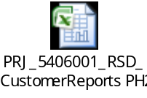

Customer User Reports

To enable access to Data Warehouse, a link will be provided to the customer user on the web channels’ Services tab. Clicking on the link will launch the relevant CE10 screen that the customer has access to.

This link is visible to the user only if they have access to reporting. This is a user level flag that defaults to “No access” to reports.

The architecture of the reporting integration with NG will remain similar to what it currently is. HP Next Gen Web Design resources will be creating interfaces to CE10 to fetch the report meta-data from CE10 and display report filter forms based on the meta data. HP will also develop the web pages that call these interfaces and display the data .

Transaction Log Reports

These will be handled by webtrends.

Master System

The system of record for all the above mentioned data is Sterling.

Implementation Details

Entity objects.

Actions involved and Functions

Process Flow

Field Mapping

N/A

Schema
N/A

Screen Shot

[TBD] – Insert screenshot of the Services tab with the reporting links.

Open Questions
- Confirm the parameters need to be passed in the link to Crystal Reports so that the customer user lands on the appropriate page? [Prashant – 7/23 – Based on Reporting JAD 7/1, the existing model will be used and it involves interface calls rather than passing paramaters.]
- Is there any reporting required from Call Center? [ Prashant – 7/23 – Based on Ryans response – No]
- Xpedx to provide the 12 classes of events that are pulled from the transaction log into DW today. [Prashant – 7/23 – Classes provided and included in this document.] [Prashant 7/27 – Event classes will be handled by webtrends going forward and have been removed from this document]
- Is there any customer/customer user level flag to enable access to reporting?
- Who manages the user level reporting flag ? What are the default values of this flag?
- How are customer specific reports being handled in NextGen?
- If the user is authorized to multiple ship-tos, how does the user switch reporting at a specific ship-to level and at the customer level?
- Can we get a list of reports that are going to be made available so that we can analyze the fields that need to be sent to data warehouse.
- Need screenshot to show the point at which the Reporting link shows up.

Assumptions

- The reporting process will be implemented similar to what exists today.
- This development effort will be done by HP with oversight and accountability for the Design and Architecture By Sterling Commerce, however xpedx and HP will jointly be responsible for the schedule.

Connectivity Diagram

Sterling to Crystal Reports Connectivity Diagram

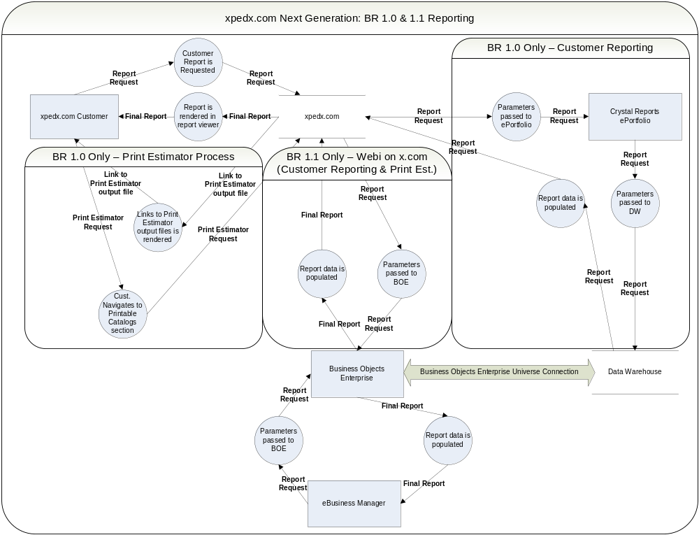

Connectivity Process

The sequence of events for reports is as follows –
- A customer user opens the services tab, where a list of reports that she/he has access to is display. This list is obtained by making a call to the Crystal Reports ePortfolio.
- Once the user selects a particular report, another call is made to Crystal Reports ePortfolio to retrieve the selectable parameters of the report.
- Once the user enters values for the parameters and submits the request, another interface call is made to Crystal Reports ePortfolio that returns the report data that is to be displayed to the user.

Note: This is the process for BR1 for reports.

Glossary of Terms

S. No. | Term | Definition
1. | WSDL | Web Services Definition Language
2. | UE (User Exit) | Hooks to write custom code in Sterling
3. | MQ | Message Queue
4. | BR1 | Business Release 1
5. | ETL | Extract, Transform and Load
6. | DW | Data Warehouse

